Subject: Discrete Mathematics
EXERCISES - CHAPTER 3: The fundamentals: Algorithms, the Integers, and Matrices

Book: Discrete Mathematics and Its Applications, 6th Edition
Author: Kenneth H. Rosen
Publisher: McGraw-Hill International Edition
Total: 14 exercises

178 | 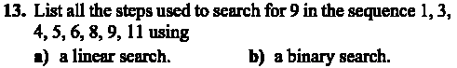
191 | 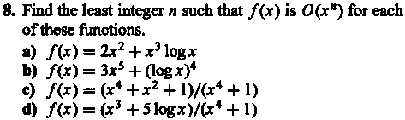
200 | 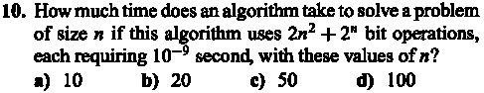
208
209 | 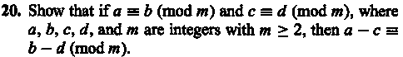  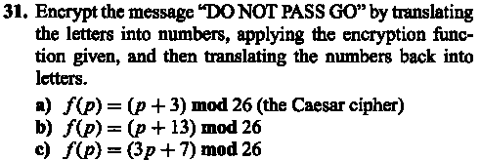  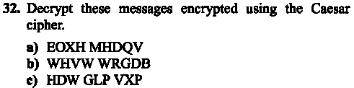
218 | 